**Senior Leadership Team (SLT) - Quality, Safety and Governance**

**20 October 2024**

|  |  |  |  |  |
| --- | --- | --- | --- | --- |
| **Paper title:** | Learning from deaths and Patient Safety Incident Investigations | | | **Agenda**  **Item**  **XX** |
| **Presented by:** | Dr David Sims, Medical Director | | |
| **Prepared by:** | Sallie Turner, Mortality & Duty of Candour Improvement Facilitator / Rachel Howitt, Head of Patient Safety, Compliance and Risk | | |
| **Committees where content has been discussed previously** | | n/a | | |
| **Purpose of the paper**  Please check **ONE** box only: | | For approval  For discussion | For information | |

|  |  |  |
| --- | --- | --- |
| **Relationship to the Strategic priorities and Board Assurance Framework (BAF)** | | |
| The work contained with this report contributes to the delivery of the following themes within the BAF | | |
| Being the Best Place to Work | Looking after our people |  |
| Belonging to our organisation |  |
| New ways of working and delivering care |  |
| Growing for the future |  |
| Delivering Best Quality Services | Improving Access and Flow |  |
| Learning for Improvement | √ |
| Improving the experience of people who use our services | √ |
| Making Best Use of Resources | Financial sustainability |  |
| Our environment and workplace |  |
| Giving back to our communities |  |
| Being the Best Partner | Partnership |  |
| Good governance | Governance, accountability & oversight | √ |

|  |
| --- |
| **Purpose of the report** |
| The purpose of this report it to provide Board with an overview of the learning the Trust has taken from the deaths of patients within its care during Q2, 2024/25. |

|  |  |
| --- | --- |
| **Executive Summary** | |
| Learning from deaths is supported by two key policies in Bradford District Care Foundation Trust (BDCFT), the Patient Safety Incident Response Policy (PSIRP) and the Learning from Deaths (LfD) Policy. These policies guide and inform the organisation about reporting, investigating and learning from deaths. Between 01 July 2024 and 30 September 2024 there have been 63 deaths reported. This is only a slight increase on the same period in the previous year.  **5** Patient Safety Incident Investigation reports have been completed for 5 deaths. **2 LLRs** and **1 SJR** monitored via the patient safety process have been completed this quarter, along with **4** completed SJRs and **1 LLR**, commissioned by the Patient Safety Executive Panel (PSEP).  Learning from excellence and learning for improvement was identified in all cases and continues to be shared with teams and across the organisation. | |
| Do the recommendations in this paper have any impact upon the requirements of the protected groups identified by the Equality Act? | **Yes** (please set out in your paper what action has been taken to address this)  **No** |

|  |
| --- |
| **Recommendation(s)** |
| The SLT - Quality, Safety and Governance group is asked to:     * Note the content of the report and take assurance that our processes for reviewing and learning from deaths is robust and appropriate |

|  |  |  |
| --- | --- | --- |
| **Links to the Strategic Organisational Risk register (SORR)** | The work contained with this report links to the following corporate risks as identified in the SORR: | |
| **Care Quality Commission domains**  Please check **ALL** that apply | Safe  Effective  Responsive | Caring  Well-Led |
| **Compliance & regulatory implications** | The following compliance and regulatory implications have been identified as a result of the work outlined in this report:   * n/a | |

**SLT - Quality, Safety and Governance**

**20 October 2024**

**Learning from Deaths 2024/2025 Q2**

**Introduction and background**

Learning from deaths is supported by two key policies in BDCFT; the Patient Safety Incident Response Policy (PSIRP) and the Learning from Deaths (LfD) Policy. These policies guide and inform the organisation about reporting, investigating and learning from deaths.

**Current Status**

Between 01 July 2024 and 30 September 2024, a total of 63 of Bradford District Care NHS Foundation Trust’s patients died. There were 55 in Q2 last year.

During Q2 there were 2 reported deaths with a Learning Disability (Service User with registered Learning Disability) and/or a Clinical diagnosis of Autism. These have undergone Learning for Lives and Deaths (LeDeR) service improvement reviews.

Table 1: Number of reported patient deaths per quarter (rolling 12 months)

|  |  |  |  |  |
| --- | --- | --- | --- | --- |
|  | Quarter 3  23/24 | Quarter 4  23/24 | Quarter 1  24/25 | Quarter 2  24/25 |
| Number of patients who have died during previous 12 months | Oct – 36  Nov – 24  Dec - 38 | Jan – 21  Feb – 26  Mar - 27 | April – 21  May – 24  June - 25 | Jul – 20  Aug – 21  Sept – 22 |
| Total per quarter | 98 | 74 | 78 | 63 |
| Total number of patients who have died in the last 4 quarters | 313 | | | |

All deaths, whether expected due to a clinical condition or unexpected, are reviewed bi-weekly in the Patient Safety Executive Panel (PSEP) which aligns with good governance processes under the Patient Safety Incident Response Framework (PSIRF) requirements which commenced in April 2024.

This group commissions reviews of case notes from a sample of deaths using the Structured Judgment Review (SJR) tool. This is a national tool developed by the Royal College of Psychiatrists to allow clinicians to take an expert view of the care offered. The Group may also commission initial reviews which do not consider the full range of factors within the SJR review to understand if an SJR is appropriate, or where an SJR is not required but where there may be learning, other review methods may be used for example a Local Learning

Review (LLR), After Action Review (AAR) or Thematic Analysis (TA) to identifying learning in order to minimise the risk of future harm.

The Patient Safety Executive Panel considers the outcomes of the reviews and asks the relevant Quality and Operational (QuOPs) meeting to develop an action plan in regard to any areas where it has been suggested that care should be improved. Issues that are of general relevance will be added to the trust Patient Safety and Learning page to enable broader sharing across the organisation. For all deaths of patients who have a Learning Disability, the initial review is shared in the Patient Safety Executive Panel and they are referred to the national Learning for Lives and Deaths (LeDeR) programme.

The Mortality screening tool, embedded on Safeguard, continues to enable reporters to provide more complete information regarding deaths at an earlier point. This is helping facilitate the decisions at PSEP regarding level of review/investigation required.

The number of deaths in each quarter for which an SJR or Patient Safety Incident Investigation (PSII) was carried out are shown in the following table:

|  |  |  |  |  |
| --- | --- | --- | --- | --- |
|  | Quarter 3  23/24 | Quarter 4  23/24 | Quarter 1  24/25 | Quarter 2  24/25 |
| Number of deaths for which a Structured Judgement Review was completed | 9* | 6* | 5* | 5 |
| Number of deaths for which a Local Learning Review was completed | *\*Not previously broken down by type, figures included in the above\** | | | 3 |
| Number of deaths for which an After Action Review was completed | 0 |
| Number of deaths for which a PSII was completed | 5 | 4 | 3 | 5 |

Please note:

**2 LLRs** and **1 SJR** monitored via the patient safety process are for deaths that both occurred and the reviews were completed in Q2. 2 further LLR’s for deaths that occurred in Q2 remain open and ongoing.

**1** **SJR** monitored via PSEP was commissioned in the Q2 period, but the completed review will be included in the next quarters figures.

**All 4** of the completed **SJR’s** monitored via PSEP, were deaths that occurred in the previous reporting period and the reviews were completed in this reporting period.

**All 5** **PSII** investigations were for deaths that occurred in previous reporting periods and the investigations were completed in this reporting period (Q2 24/25).

All types of incident response (PSII, SJR, LLR or AAR) have the same remit of identifying system learning for improvement.

**Learning and improvement**

BDCFT takes a proactive approach to learning from deaths and the following summary highlights where good practice and areas identified for improvement have been highlighted during Q2, 2024/25. This learning is used to shape future quality and safety improvements.

Learning from good and excellence:

A number of reviews were conducted that concluded good and excellent care had been provided by various inpatient and community teams. The aspects of care identified as demonstrating this were:

* Clinicians **liaised with key physical health services** at the Bradford Royal Infirmary to provide **holistic care** to the patient.
* **Follow up** by the Step Forward Centre with the patient despite him being discharged.
* Community Mental Health Team (CMHT) Duty Manager authorised an **urgent home visit** following concerns raised by the family.
* **Good communication** between services to ensure the patient’s physical health concerns were addressed and that he was receiving the correct interventions for a range of physical health concerns.
* **Good family/Advanced Nurse Practitioner (ANP) relationship,** ongoing conversations, **flexibility of appointments and swift actions** and **intervention implemented** when needed.
* **Excellent communication** with the patient by the care coordinator. The patient received **individualised care coordination**, which considered her needs and preferences.
* **Good safety planning**. It was **holistic** in nature, and in line with national and local guidance.
* Perceived **risk was effectively managed** in relation to frequency of ‘did not attend (DNA)’ appointments and sufficient reengagement processes were followed.
* Mood stabilisers and antidepressant were **prescribed in line with national guidance**.
* **Policies and procedures were followed** during contacts with BDCFT First Response Service (FRS).
* **Regular review by the CMHT team and care co-ordinator**. When medication changes were occurring, the patient was **reviewed more frequently in clinic**.
* **Patient information leaflets** were shared so that the patient could review and consider the options at home and decide which medication he would like to choose.
* **Shared decision making**. **Clear documentation** of dependency risk when reviewing the initiation of pregabalin. Good use of acute prescription and small quantities to cover periods of increased anxiety.
* Good recognition during **telephone triage** of patient’s difficulty with timely face-to-face response and assessment with **acknowledgement** of family’s concerns.
* **Good patient follow up** and regular psychiatrist appointments, which showed good practice and care, despite no change in presentation or risks.
* **All round support** was provided for attending physical health needs, assessing physical and mental state and ensuring the patient had cold weather provisions.
* Staff remained **determined** to find suitable accommodation despite most options being exhausted, **organising professional meetings** to explore housing options and possible solutions.
* Ongoing risks of vulnerability and self-neglect were **extensively followed up**.
* **Clear communications** were provided to the patient about the outcomes of the assessment along with crisis contact numbers.

Learning for improvement:

Some learning was identified from a number of reviews where care had not gone so well, and improvements could be made. An action plan is developed for all events where learning is identified and is monitored through the operational quality improvement processes in the Trust, with oversight in the Patient Safety and Learning Group (PSLG). Examples of the learning identified relate to:

* **Highly complex patient** on the Child & Adolescent Mental Health Service (CAMHS) Looked After Adopted Children (LAAC) caseload **allocated to a junior staff member.**
* **Discharged** from CAMHS LAAC back to the care of GP, **without the provision of Adult Mental Health services**.
* A **significant passage of time between the patient’s initial referral** **and the first face-to-face contact.** During this time frame the patient engaged in suicidal behaviour on at least two known occasions.
* Completion of **leave assessment forms and leave return forms** were not fit for purpose.
* **Delays** in completion and sending of **discharge documentation to the General Practitioner (GP).**
* Some care provided was **not in line with policy expectations** and action to demonstrate **understanding about the roles and responsibilities of the Care Coordinator** were not evidenced throughout the care period.
* **Documentation** and monitoring in relation to the **Case Management Reviews** undertaken was not fit for purpose.
* The **system** for notifying and/or **monitoring of changes to the status of Honorary Workers** is not fit for purpose.
* **No clear pathway from referral**, of which professional role is best placed to work with a service user and their family, based on **risk assessment and complexity of need**.
* **GPs being unable to initiate antipsychotic prescribing**, and **long Community Mental Health Assessment Team (CMH AT) waiting lists**.
* No formal **Care and Safety Plan** had been completed and the Clinical **Risk Assessment questionnaire** had not been updated for 17 months; however, care plans and risk information were documented in the tabbed journal of the clinical records at each contact with the ANP.
* There was a **communication** issue following a joint review appointment in the month before the patient’s death.
* There was a **delay in initiating Cardiopulmonary resuscitation (CPR)** at the moment of finding the patient. This was in the context of previous non-responsive presentations when the patient roused and became aggressive.
* **Uncertainty about the Do Not Attempt Cardiopulmonary Resuscitation (DNACPR)/ReSPECT status of the patient.**
* Lack of standard process for assessing **DNACPR/ ReSPECT** status.
* BDCFT policy on **death and dying procedure was not adhered to.**
* Venous Thromboembolism (VTE) risk and treatment was considered but the **discussion and decision making was not recorded in the clinical record.**
* The “**box” referred to in BDCFT’s Death and Dying policy** to conduct last offices was **not able to be located following this incident.**
* Advanced Life Support (ALS) was attempted however is not directed within BDCFT’s resuscitation policy and therefore **required adrenaline not routinely stocked in the emergency bags held on the ward.**
* Lack of awareness about roles in relation to **notifying the Coroner after a death**.
* Incorrect documentation - **risk assessment** and **medication change discussions** **documented in the wrong service user record**.
* There was **no documented review of the patient's medication regimen**, and therefore a **missed opportunity to re-evaluate the patient’s medication management strategy**.
* During the patient’s assessment there was **no contact made** with the police, PREVENT or the safeguarding team **for information sharing and support**, which would have **clarified the nature and extent of risks** and encouraged a multi-agency approach towards risk assessment and support to the patient and his family.
* Considering a trauma informed approach when communicating about long **waits for assessment** to reduce patients **feeling abandoned** by services.

**Next steps**

A number of developments are ongoing to enable the workstreams in relation to mortality to improve and mature.

The Patient Safety Executive Panel (PSEP) is now well established and continues to provide the governance structure for the learning from deaths work and the Patient Safety Incident Response Framework (PSIRF) requirements.

The Trusts Mortality Data Audit has been completed in Q2 by Audit Yorkshire, who provided an overall opinion of **significant assurance.** This classification confirms that:

* The Trust records, analyses and monitors the total number of patient deaths.
* Mortality data is regularly reported through the Senior Leadership Team – Quality, Safety and Governance meeting enabling challenge.
* The Patient Safety Executive Panel identifies potential themes for review from the deaths within mental health and learning disability services that pass through it.
* The Trust engages with the local authority and Place-based and regional suicide prevention groups to inform data-driven localised suicide prevention activity.

5 recommendations (3 minor, 2 moderate) have been noted within the findings which are currently being progressed ahead of the end of 2024 deadline.

The Mortality Dashboard, within the Trusts’ Incident Report and Risk Register System, continues to build on refining data analysis and incorporating patterns, trends and themes for incorporating into the coming quarterly reporting periods.

BDCFT participates in the ‘Northern Alliance’ of mental health trusts, which focusses on mortality review processes, providing a regional network for identifying and sharing opportunities for learning and improvement. We have recently collaborated with some members of the Alliance to review and improve how learning from deaths is reported across place for better alignment of mortality metrics.

The PSEP group receives a Coroners Learning from Deaths Summary Report on a monthly basis. This provides a summary of national Prevention of Future Death Reports and is also received by the Patient Safety and Learning Group (Insights) to inform triangulation and any safety action required. The statutory ME process and death certification reform went live on 09 September 2024.

In addition, other ongoing developments include:

* Evaluating how assurance is received that appropriate learning has been identified and actions taken as a result in order to minimise the risk of future harm
* Continuing to embed PSIRF by ensuring appropriate response to patient safety incidents, including deaths, in a way that is in line with legislation, best practice and guidance and actively promotes and supports a just learning and generative safety culture across the organisation
* Supporting the use and development of systems-based PSIRF approaches to incident response
* A review of how SJR score breakdowns and narrative can be developed to triangulate data and enhance learning.
* Further refinement to published learning from deaths data.

**Conclusion**

For Q2, 2024/25 there has been a 14% increase on the number of deaths reported compared to the same period last year. There has been a 19% decrease in the number of deaths reported in Q2 of 2024/25 compared to Q1 of 2024/25.

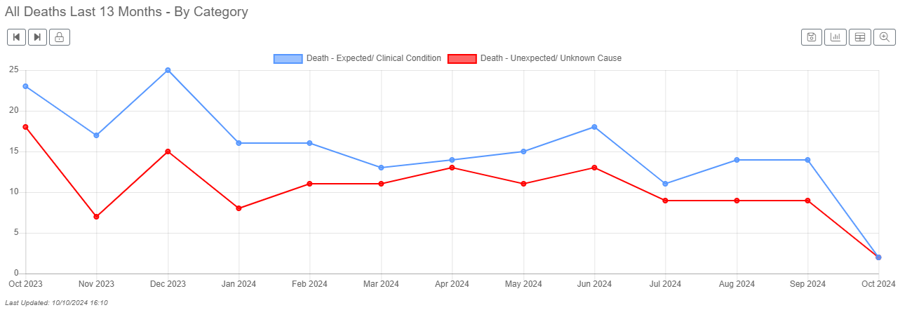

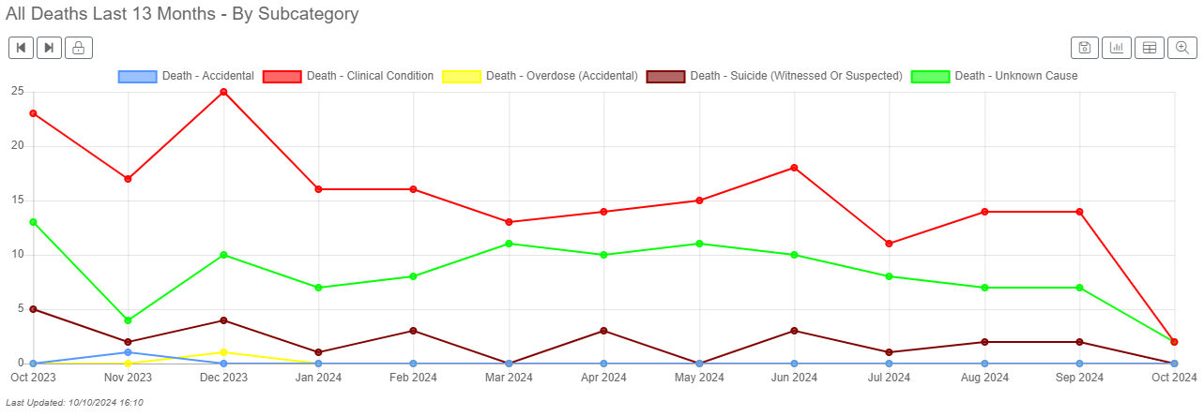

Death under the care of the National Health Service (NHS) is an inevitable outcome for some patients and patients may experience good and excellent care in the months or years leading up to their death. The reporting of deaths and governance arrangements support BDCFT to identify learning where care could be improved and where the good practice can be shared. The reports indicate that the learning required arises from multiple contributory factors, which are system-wide issues and feed into quality improvement activity.

**Sallie Turner**

**Mortality & Duty of Candour Improvement Facilitator**

**Rachel Howitt**

**Head of Patient Safety / Patient Safety Specialist**

**14 October 2024**