Helping with narrative skills in Early Years

User Guide:
Black Sheep Press Nursery Narrative

The  intervention | 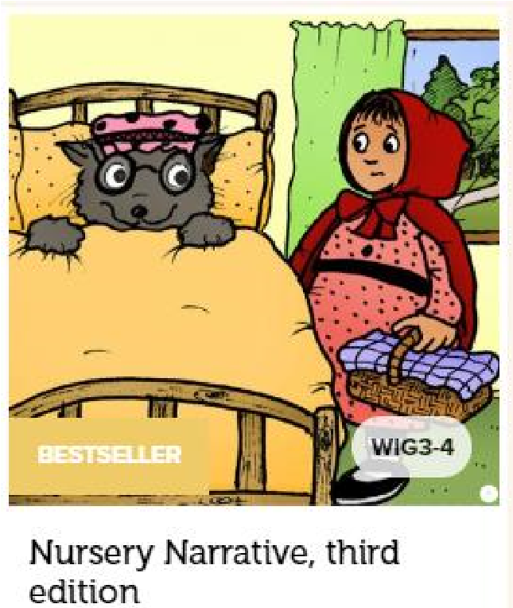  Nursery Narrative, third edition
Where to find it.  How much  does it cost? | Nursery Narrative, third edition - Black Sheep Press  £68
What does it target? | Early language skills; in particular narrative skills.
Who is it for? | Early Years.
What is it? | This pack introduces the narrative structure of ‘who’, ‘where’, ‘when’ and ‘what happened’ and is designed to allow practitioners to enrich the language skills of children within their classroom.
How does it work? | It is designed to be run with groups of 4-6 children but a lot of the activities lend themselves to larger groups.
Who can deliver it? | Teachers, Teaching Assistants and Speech and Language Therapists.
How long does it take? | Run twice a week for 10 weeks, each session lasting approximately 30 minutes depending on the attention levels of the children in the group.
What resources do I need? | The programme has the majority of resources. It lists any additional resources you require in each session plan. You may need some toys from around the classroom to help re-enforce learning through real objects.
How do I show progress? | Black Sheep Press recommend using their squirrel story narrative assessment (ages 3-6) at the start and end of interventions to monitor progress.  Communication Trust tracker is an alternative.  Progress against age related norms on the Early Years Foundation Stage trackers.  Before starting the interventions ask the child to retell you a story they are familiar with. Write down exactly what they say. After the interventions ask them to tell you the same story again and compare the length of sentences used, the detail provided and if they include all elements such as who, where, when and what happened next.
What next? | - Continue to use the colour coded prompt cards in class and create opportunities for children to practice using their narrative skills.  - If a child struggled with any particular element, repeat some of the sessions again.  - Black Sheep Press also have a reception narrative pack.
Top Tips | - Use real objects alongside the pictures where possible to help support children’s learning of new vocabulary.  - Allow time to print and prepare for sessions, there are a lot of paper resources. However once this is done it can be reused every year.  - Be mindful of the colour coded prompt cards – ensure they match with any other colour coding being used in school as the Colourful Semantics colours are different.  - The Makaton website has useful core signs and tips for signing.  (makaton.org).
Additional resources | See Black Sheep Press Website.
Evidence Base | See Black Sheep Press Website.  The pack has information on studies included.

Office use: 00625v1
Review date: November 2023

