Helping with speech sounds

User guide:
Time for sounds – sound awareness – reception level.

The  intervention | 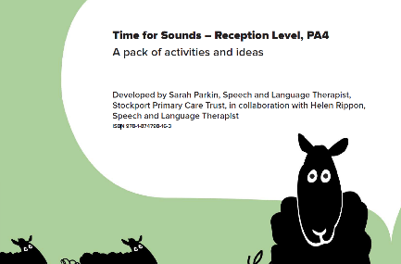  Time for sounds – sound awareness – reception level.
Where to find it?  How much  does it cost? | https://www.blacksheeppress.co.uk/product/time-sounds-reception-sound-awareness/  The cost of the resource is £70.00 + VAT.
What does it target? | Phonological awareness skills.
Who is it for? | Children in Foundation Stage – KS1.  It is designed to support the development of phonological skills in children who have been identified as having:  - delayed attention and listening skills.  - speech sound errors .  - and / or as not developing phonological awareness skills at the expected rate.  Sessions are intended for a group of 6 children. The activities may be adapted and group sizes may also be varied. It can be used on an individual, small group or whole class basis.
What is it? | The program aims to develop children’s phonological awareness. Focus areas include:  - Syllable segmentation and blending.  - Rhyme generation.  - Identification of phonemes.  - Onset and rime.  Links to curriculum targets: Letters and Sounds; Phase 1–3.
How does it work? | There are 8 sessions in this program. Each session has with a range of activities, with a session plan to guide the adult. 30-45 minutes is the recommended time per session, but length of sessions can be tailored depending on group size and the attention and listening skills of the child/ren.  The use of a visual schedule throughout activities is used to support children’s attention and listening.  The resource contains visual prompts to use within each session e.g.  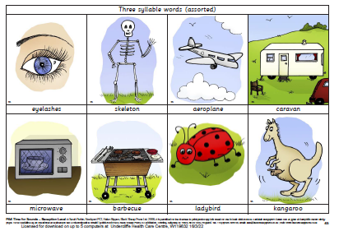  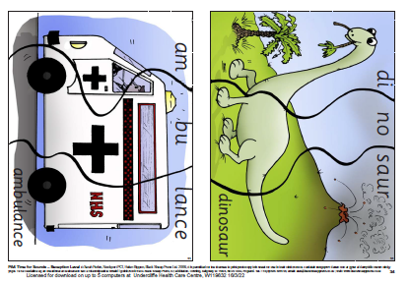  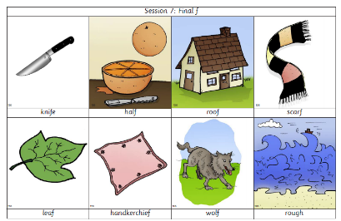  This programme is not designed to replace the targeted phonic programe used within your setting.
Who can deliver it? | A teaching assistant or teacher.
How long does it take? | There are 7 sessions , with a guide of 30-45 minutes. In the pilot study, sessions were carried out twice a week by a learning support assistant – with liaison with class teacher and speech and language therapist.
What resources do I need? | The programme provides session plans and all resources required to run the intervention.
How do I show progress? | You could use a phonological awareness screening tool, such as https://www.hertfordshire.gov.uk/microsites/local-offer/media-library/documents/resource-area-documents/spld-phonological-awareness-pack-pdf-6mb.pdf (Screening tool from page 93 onwards.)
Top tips | - Try to carry out these activities in as distraction free environment as possible. Reduce background noise and visual distractions.  - Keep groups small so children don’t have to wait too long for their turn.  - Lots of repetition will be required.  - Use short, clear instructions.  - Model activities so children can see what to do first.  - Don’t make sessions too long to support attention levels.
Evidence  base | https://www.blacksheeppress.co.uk/wp-content/uploads/2017/01/PA4_Research.pdf details findings from the pilot study.

